TOPIC-ReactJS-HOL  
Q.1.) Create a new React Application with the name “myfirstreact”, Run the  
application to print “welcome to the first session of React” as heading of that  
page.  
Solution:  
Code:-  
Path: src/App.js  
import React from 'react';  
function App() {  
return (  
<div>  
<h1>Welcome to the first session of React</h1>  
</div>  
);  
}  
export default App;  
OUTPUT:

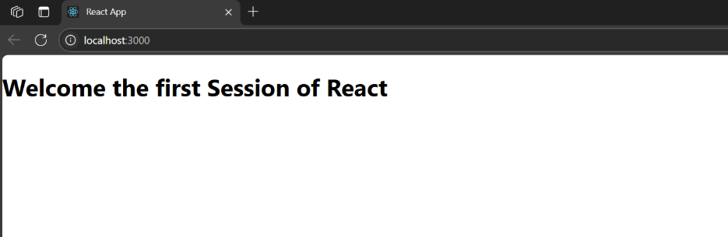  
Q.2.) Create a react app for Student Management Portal named StudentApp  
and create a component named Home which will display the Message  
“Welcome to the Home page of Student Management Portal”. Create another  
component named About and display the Message “Welcome to the About

page of the Student Management Portal”. Create a third component named  
Contact and display the Message “Welcome to the Contact page of the  
Student Management Portal”. Call all the three components.  
Solution:  
Code:-  
Path: src/Components/Home.js  
import React from 'react';  
function Home() {  
return (  
<div>  
<h2>Welcome to the Home page of Student Management Portal</h2>  
</div>  
);  
}  
export default Home;  
Path: src/Components/About.js  
import React from 'react';  
function About() {  
return (  
<div>  
<h2>Welcome to the About page of the Student Management Portal</h2>  
</div>  
);  
}  
export default About;

Path: src/Components/Contact.js  
import React from 'react';  
function Contact() {  
return (  
<div>  
<h2>Welcome to the Contact page of the Student Management Portal</h2>  
</div>  
);  
}  
export default Contact;  
Path: src/App.js  
import React from 'react';  
import './App.css';  
import Home from './Components/Home';  
import About from './Components/About';  
import Contact from './Components/Contact';  
function App() {  
return (  
<div className="App">  
<Home />  
<About />  
<Contact />  
</div>  
);  
}  
export default App;

OUTPUT:-

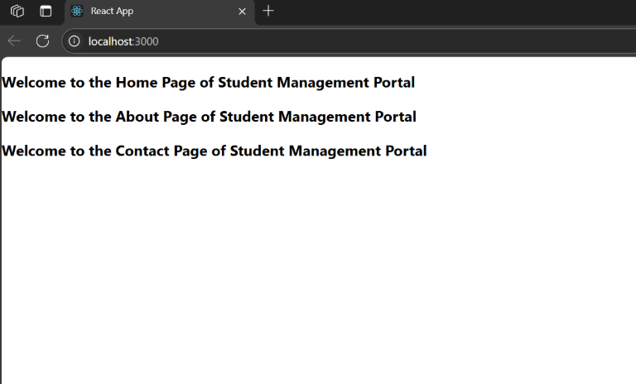

Q.3.) Create a react app for Student Management Portal named  
scorecalculatorapp and create a function component named “CalculateScore”  
which will accept Name, School, Total and goal in order to calculate the  
average score of a student and display the same.  
Solution:

CalculateScore.js  
import React from 'react';

const CalculateScore = ({ name, school, total, goal }) => {

const average = total / goal;

return (

<div>

<h2>Student Score Details</h2>

<p><strong>Name:</strong> {name}</p>

<p><strong>School:</strong> {school}</p>

<p><strong>Total Marks:</strong> {total}</p>

<p><strong>Goal Subjects:</strong> {goal}</p>

<p><strong>Average Score:</strong> {average.toFixed(2)}</p>

</div>

);

};

export default CalculateScore;

INDEX.CSS

body {

margin: 0;

padding: 0;

font-family: 'Segoe UI', Tahoma, Geneva, Verdana, sans-serif;

background-color: #f2f6ff;

}

.App {

max-width: 600px;

margin: 40px auto;

background: #fff;

border-radius: 12px;

box-shadow: 0 4px 20px rgba(0, 0, 0, 0.1);

padding: 30px;

text-align: center;

}

h1 {

color: #2c3e50;

margin-bottom: 25px;

}

h2 {

color: #34495e;

margin-bottom: 15px;

}

p {

font-size: 16px;

color: #555;

margin: 10px 0;

}

strong {

color: #2c3e50;

}

INDEX.JS

import React from 'react';

import ReactDOM from 'react-dom/client';

import App from './App';

import './index.css'; // Optional: for styling

const root = ReactDOM.createRoot(document.getElementById('root'));

root.render(

<React.StrictMode>

<App />

</React.StrictMode>

);

App.js

import React from 'react';

import CalculateScore from './CalculateScore';

function App() {

return (

<div className="App">

<h1>Score Calculator App</h1>

<CalculateScore name="Affreen" school="GHSS" total={480} goal={6} />

</div>

);

}

export default App;

OUTPUT:

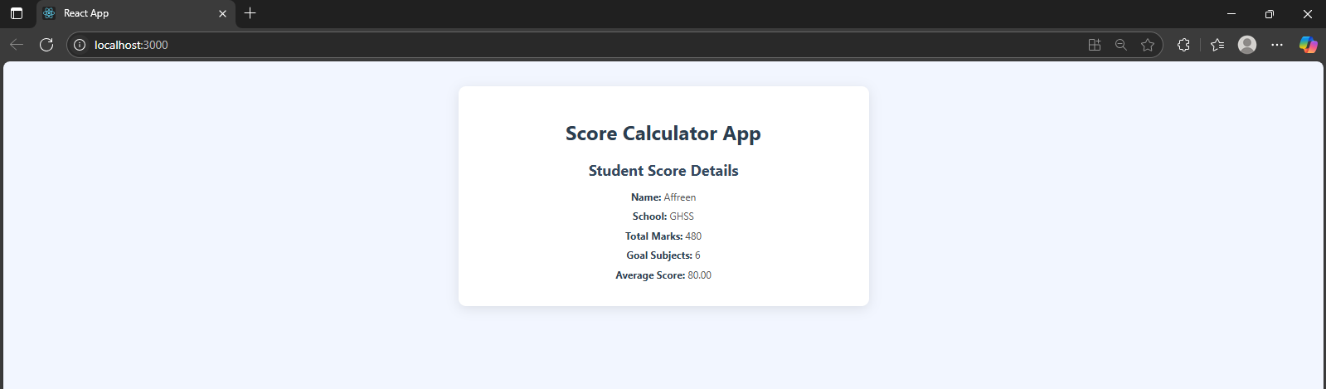

Q.4.) Create a new react application using create-react-app tool with the  
name as “blogapp”.  
Solution:  
Code:-  
from fpdf import FPDF

# Create a PDF document

pdf = FPDF()

pdf.add_page()

pdf.set_auto_page_break(auto=True, margin=15)

pdf.set_font("Arial", size=10)

# Title

pdf.set_font("Arial", "B", 14)

pdf.cell(200, 10, txt="Blog App React Project Code", ln=True, align='C')

pdf.ln(5)

# Function to add code block

def add_code_block(title, code):

pdf.set_font("Arial", "B", 12)

pdf.cell(200, 10, txt=title, ln=True)

pdf.set_font("Courier", size=8)

for line in code.splitlines():

pdf.multi_cell(0, 5, txt=line)

pdf.ln(5)

# App.js code

app_js = """import React from 'react';

import BlogPost from './BlogPost';

import './App.css';

function App() {

return (

<div className="App">

<h1>My Blog</h1>

<BlogPost

title="React is Awesome"

author="Affreen"

content="React lets you build user interfaces using components. It's powerful, reusable, and easy to learn. You can manage state, use hooks, and create responsive apps easily."

/>

<BlogPost

title="Getting Started with Machine Learning"

author="John Doe"

content="Machine learning is a branch of AI that uses data to train models and make predictions. Python libraries like Scikit-learn, TensorFlow, and PyTorch are popular for ML development."

/>

<BlogPost

title="Why You Should Learn JavaScript"

author="Jane Smith"

content="JavaScript is the backbone of web development. It works with HTML and CSS to create dynamic pages. Frameworks like React, Vue, and Angular are built on it."

/>

<BlogPost

title="My First Coding Experience"

author="Affreen"

content="I started learning to code with Python. At first, it was challenging, but building small projects gave me confidence. Now, I enjoy exploring AI and web development!"

/>

</div>

);

}

export default App;

# BlogPost.js code

blogpost_js =import React from 'react';

const BlogPost = ({ title, author, content }) => {

return (

<div className="blog-post">

<h2>{title}</h2>

<h4>By {author}</h4>

<p>{content}</p>

<hr />

</div>

);

};

export default BlogPost;

# App.css code

app_css = body {

margin: 0;

padding: 0;

background-color: #f0f2f5;

font-family: 'Segoe UI', Tahoma, Geneva, Verdana, sans-serif;

}

.App {

max-width: 800px;

margin: 40px auto;

padding: 30px;

background-color: #ffffff;

border-radius: 12px;

box-shadow: 0 0 15px rgba(0, 0, 0, 0.1);

}

h1 {

text-align: center;

color: #2c3e50;

margin-bottom: 40px;

}

.blog-post {

background-color: #f9f9f9;

border-left: 5px solid #3498db;

padding: 20px;

margin-bottom: 25px;

border-radius: 8px;

transition: transform 0.2s ease;

}

.blog-post:hover {

transform: scale(1.02);

}

.blog-post h2 {

margin-top: 0;

color: #34495e;

}

.blog-post h4 {

margin: 8px 0;

color: #7f8c8d;

}

.blog-post p {

font-size: 15px;

color: #333;

line-height: 1.6;

}

hr {

margin-top: 20px;

border: none;

border-top: 1px solid #ddd;

}

OUTPUT:

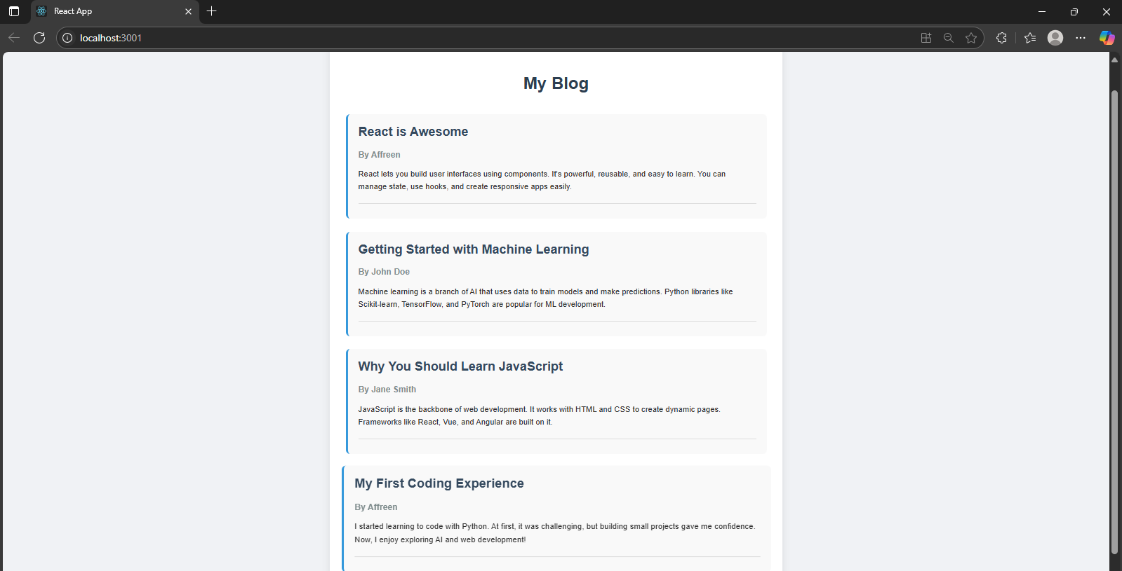

Q.5.) My Academy team at Cognizant want to create a dashboard containing  
the details of ongoing and completed cohorts. A react application is created  
which displays the detail of the cohorts using react component. You are  
assigned the task of styling these react components.  
Solution:  
Code:-

index.js  
import React from 'react';

import ReactDOM from 'react-dom/client';

import './index.css';

import App from './App';

const root = ReactDOM.createRoot(document.getElementById('root'));

root.render(<App />);

App.js

import React from 'react';

import './App.css';

import CohortCard from './components/CohortCard';

const cohortData = [

{ id: 1, name: 'AI/ML Batch 1', status: 'Ongoing', trainer: 'Mr. Arjun' },

{ id: 2, name: 'Full Stack Batch 2', status: 'Completed', trainer: 'Ms. Priya' },

{ id: 3, name: 'DevOps Batch 3', status: 'Ongoing', trainer: 'Mr. Ravi' },

{ id: 4, name: 'Data Science Batch 4', status: 'Completed', trainer: 'Ms. Swathi' }

];

function App() {

return (

<div className="dashboard">

<h1>Cognizant Academy Cohorts</h1>

<div className="card-container">

{cohortData.map(cohort => (

<CohortCard key={cohort.id} cohort={cohort} />

))}

</div>

</div>

);

}

export default App;

CohortCard.js

import React from 'react';

import './CohortCard.css';

function CohortCard({ cohort }) {

const statusClass = cohort.status === 'Completed' ? 'completed' : 'ongoing';

return (

<div className={`cohort-card ${statusClass}`}>

<h2>{cohort.name}</h2>

<p><strong>Trainer:</strong> {cohort.trainer}</p>

<p className="status">{cohort.status}</p>

</div>

);

}

export default CohortCard;

CohortCard.css

.cohort-card {

background: #fff;

border-radius: 12px;

padding: 20px;

box-shadow: 0 4px 12px rgba(0,0,0,0.1);

transition: transform 0.3s ease;

width: 300px;

margin: 10px;

text-align: left;

border-left: 8px solid transparent;

}

.cohort-card:hover {

transform: translateY(-5px);

}

.completed {

border-left-color: green;

}

.ongoing {

border-left-color: orange;

}

.status {

font-weight: bold;

}

App.css

.dashboard {

text-align: center;

padding: 30px;

background-color: #f5f5f5;

min-height: 100vh;

}

.card-container {

display: flex;

flex-wrap: wrap;

justify-content: center;

gap: 20px;

}

OUTPUT:

